Now, let's talk about the HTTP Response.

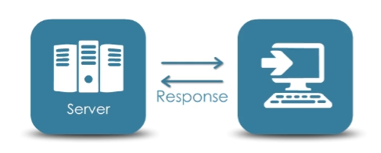After receiving and interpreting a request, the server will respond and send something back to the client.

Of course you will have a Request Body, which will contain either data or some HTML back to the client. In our case with Web API the Request Body will be data in the form of JSON or XML.

The Response will also contain a Status Code that comes from the Server. The Status Code is a 3-digit integer where the first digit defines a class of responses, and the last two digits specify a specific status.

In *most* cases you will experience Status Codes that start with a **2**, **4**, or **5**.

A Status Code that *starts* with a…

**2**: indicates the request was successfully received, understood and accepted; this is what you are looking for.

**4**: indicates a Client Error, which means the request contains incorrect syntax or you're unauthorized to access the resource.

**5**: indicates a Server Error.

